# Dylan Matthews 15009851 Prog6211

Contents

Dylan Matthews 15009851 Prog6211 1

Screen shots 5

Login screen to login With sound 5

Register a user 6

Admin screen 7

View stock screen 7

Add stock for an item screen 8

Normal user screen 9

Advance object –oriented programming features 10

Inherence used: 10

Sub classes: 10

Abstract class used: 10

Sealed class 10

Sealed methods 10

Partial class 10

Interface 10

Classes the implement the interface 10

Polymorphism Used 10

Dynamic And Var 10

UML 11

Class diagrams 11

 19

Help 21

Lock stock and Barrel – dylan matthews

The progam is a stock control system.

It allows an admin to view and add stock.

Normal users can sell stock.

The program wonnt allow the stock to get negative.

# Screen shots

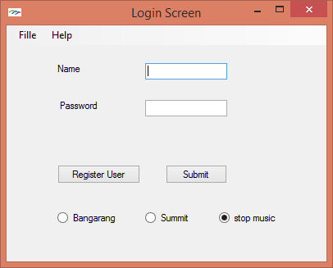

## Login screen to login With sound

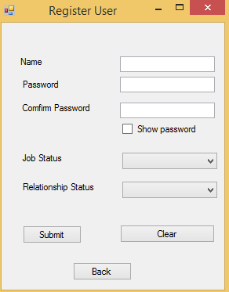

## Register a user

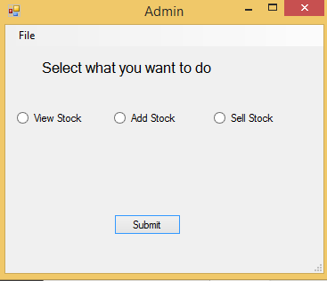

## Admin screen

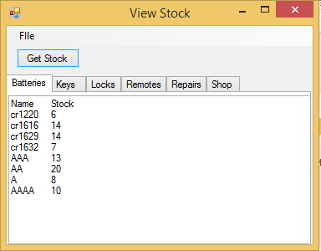

## View stock screen

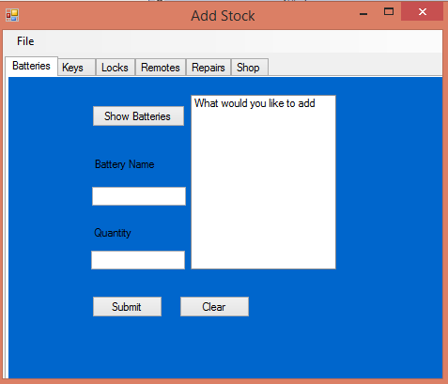

## Add stock for an item screen

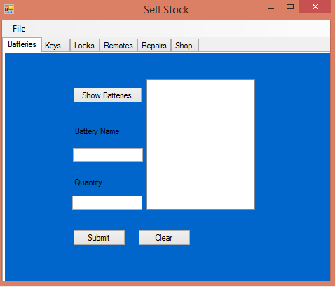

## Normal user screen

# Advance object –oriented programming features

## Inherence used:

* SuperLogin

## Sub classes:

* childLogin

## Abstract class used:

* SuperLogin

## Sealed class

* childLogin

## Sealed methods

* childLogin toString

## Partial class

* all forms with partial

## Interface

* iFailedLogin
* iExit

## Classes the implement the interface

* frmLogin

## Polymorphism Used

* its used in the sound class
* childLogin toString

## Dynamic And Var

* frmLogin

# UML

## Class diagrams



























## 



# Help

Login screen will open on launch.

You can select music and on or off and which songs.

If you login in with a normal user you will be taken to the selling screen.

From here you select the radio button which you want to sell.

Once you in an item to sell you can see the different items which you can sell.

You then type in the name and amount of stock which you want to sell.

You can exit the application at the top left with the menu button.

If you login with admin

You’ll be taken to the admin screen here you can choose to sell, add , view stock.

If you select selling.

Select the right tab which you want to sell

Once you in an item to sell you can see the different items which you can sell.

You then type in the name and amount of stock which you want to sell.

You can exit the application at the top left with the menu button.

If you select add

Select the right tab which you want to sell

Once you in an item to sell you can see the different items which you can add.

You then type in the name and amount of stock which you want to add.

You can exit the application at the top left with the menu button.

If you select view stock.

You click on the get stock button then select the tab which you want to see the stock of.